ANNUAL REPORT

ASAP

(2022-2023)

GOVERNMENTCOLLEGE CHITTUR

**TEAM OUTLOOK**

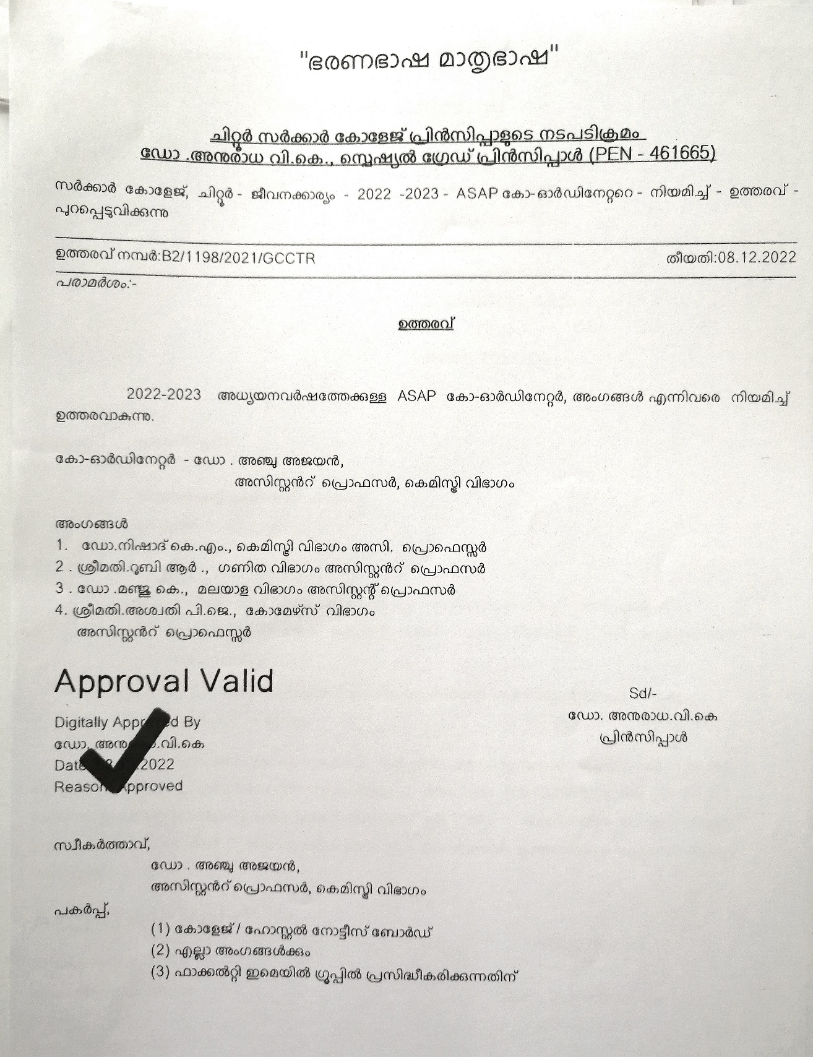

# ASAP CELL

# Additional Skill Acquisition Programme (ASAP) Kerala, an initiative of Kerala Development and Innovation Strategic Council (K-DISC) is an undertaking of the Higher Education Department, Government of Kerala, that focuses on skilling students and the general community to enhance their employability. Instituted in 2012, ASAP Kerala transitioned to a company under the Companies Act, 2013, in 2021.

# With nearly a decade of service, ASAP Kerala have become a premier government edTech company, building integrated learning and talent management solutions. ASAP Kerala has nearly become synonymous with skilling, upskilling and reskilling in corporate and academic domains, by offering 150+ contemporary courses in 19 advanced sectors and curating a ready-to-deploy workforce. We undertake training through 16 Community Skill Parks and 126 Skill Development Centers instituted across Kerala.

# Over the next four years, the Kerala Knowledge Economy Mission aims to provide gainful employment to 20 lakh people in various sectors and job fields. The Knowledge Economy Mission aims to use digital technologies as an enabler to create new knowledge that can be used to solve contemporary and future social problems, foster sustainable development, and foster intellectual growth.

# CCC (Connect Career to Campus)

# 

I had attended one day training programme for placement officers by Kerala

Knowledge Economy Mission related to connect career to Campus campaign on 11th

January 2023.

## Programmes organized by ASAP of Government College Chittur during

## the academic year 2022-2023

1. Training session for final year students to register on DWMS platform.

# The ‘Digital Workforce Management System’ (DWMS), which was developed by K-DISC, is a one-of-a-kind talent marketplace of employers, skill providers, job seekers, financial institutions, and other facilitating organizations. Digital Workforce Management is a platform that connects all stakeholders in creating a knowledge-based ecosystem. The job aspirants can finetune their career preferences and enrich their profiles to enhance their chances of getting a dream career by taking an AI-based Career Inclination Survey and Robotic Interview. We conducted DWMS registration programme for students to register on the platform on 2023 January 24.

1. Work Readiness Programme (15-hour workshop) for final year students

The **Work Readiness Programme** is a 15-hour module designed to provide direction to candidates to improve their interview skills and articulate their thoughts confidently in front of an interview panel. The module is inclusive of interview etiquette, resume preparation, presentation skills, group discussions, job-related Q&A, soft skills, etc.

## ACTIVITY 1: DWMS platform registration for final year students

## 

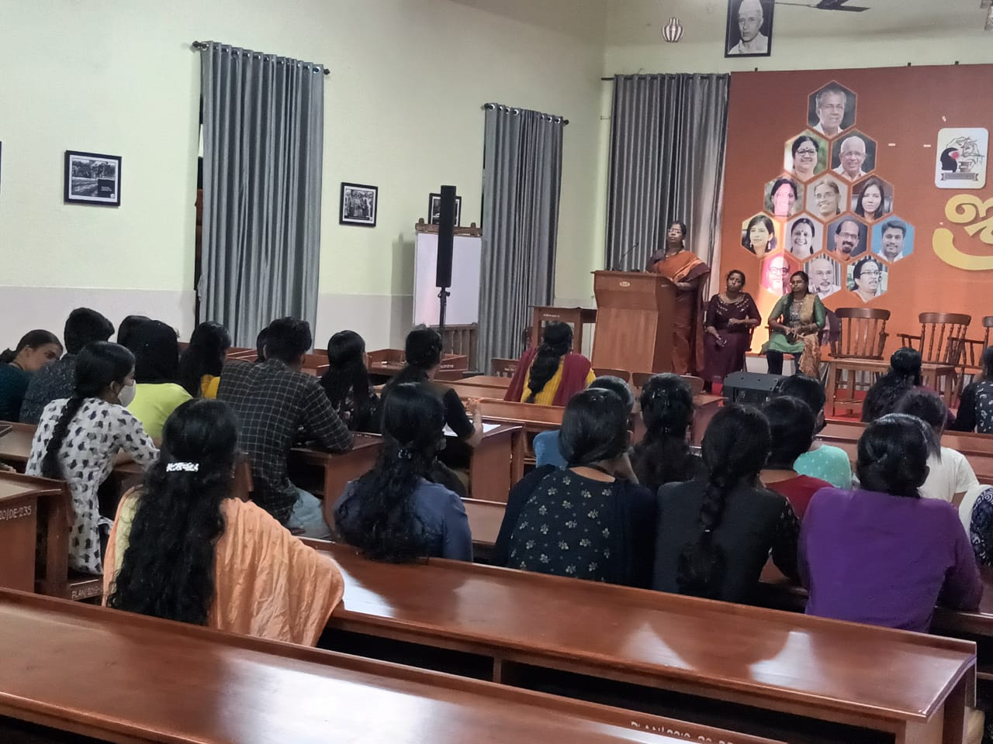

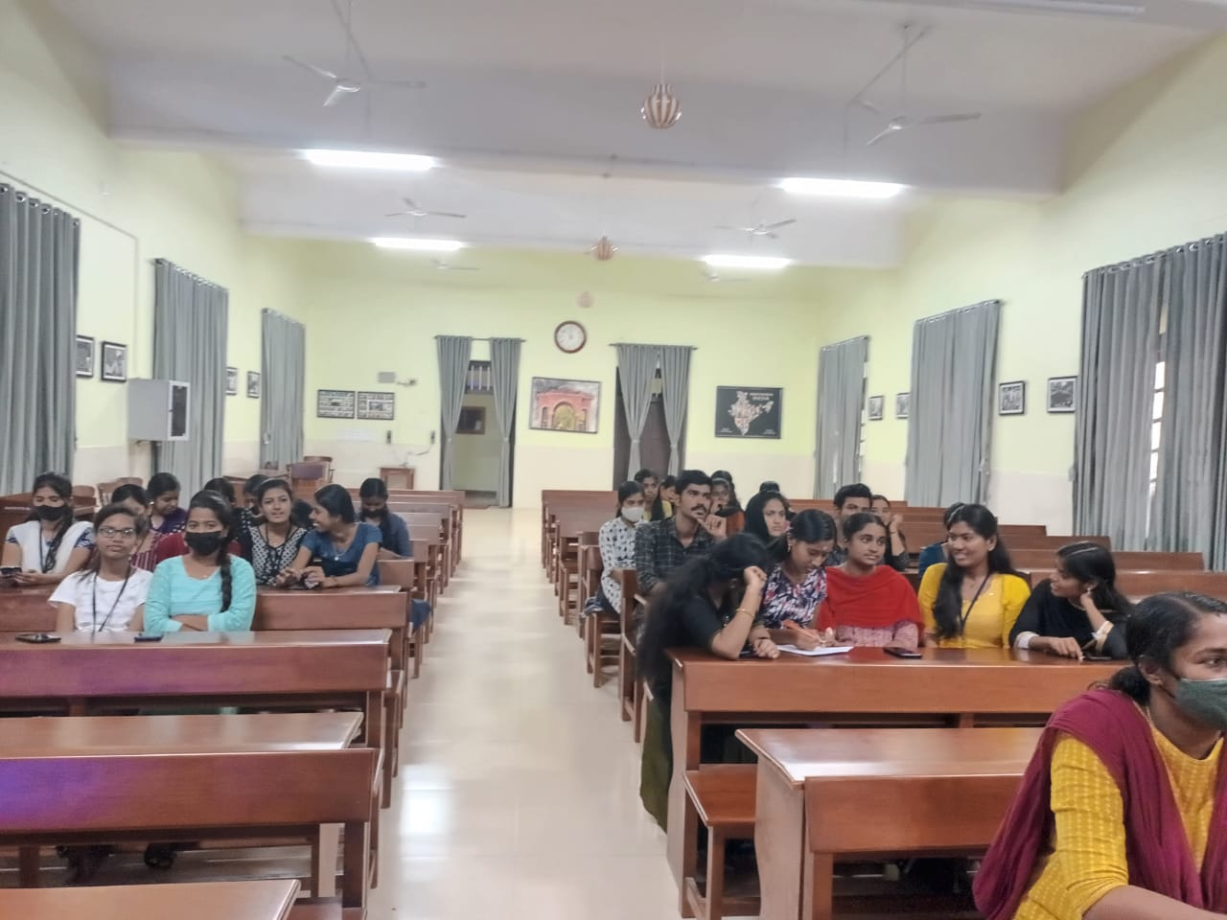

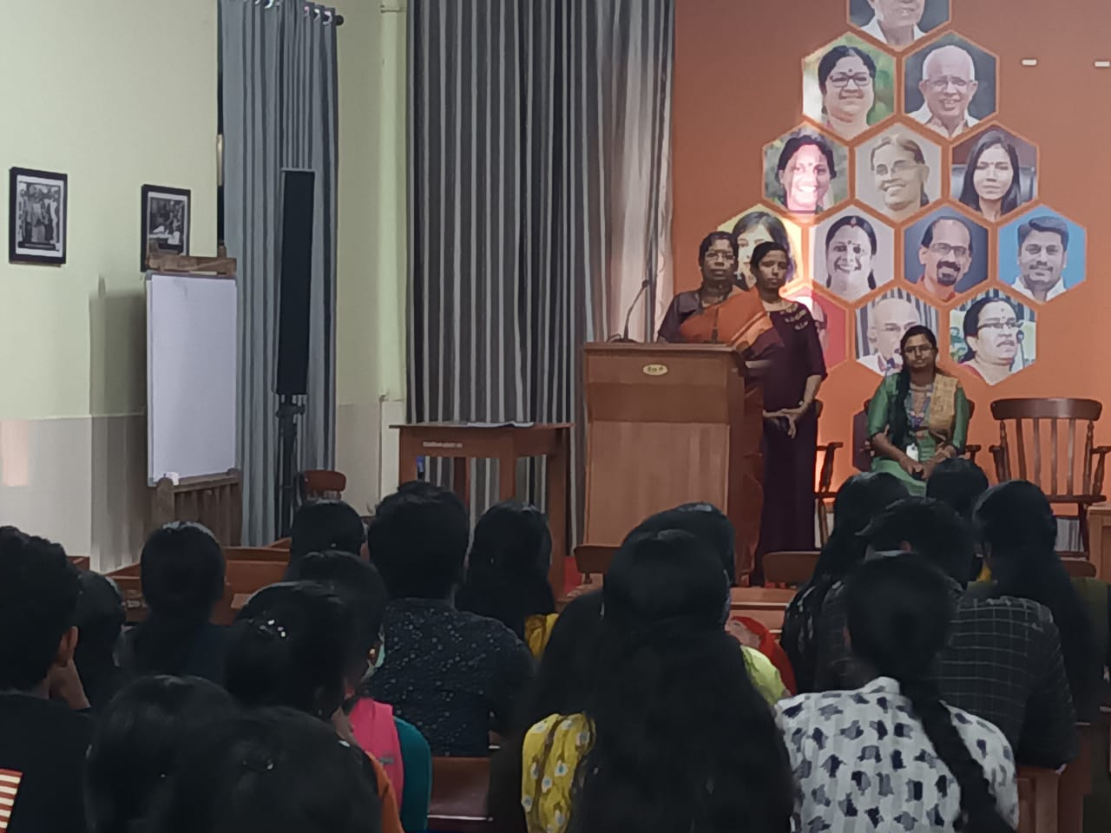

## ACTIVITY 2: 3 DAY WORK READINESS PROFRAMME

The **Work Readiness Programme** is a 15-hour module designed to provide direction to candidates to improve their interview skills and articulate their thoughts confidently in front of an interview panel. The module is inclusive of interview etiquette, resume preparation, presentation skills, group discussions, job-related Q&Asoft skills, etc.

We conducted the programme on 2023 February 24, 25 and 16 for the final year UG and PG students. Total of 26 students have participated in the workshop.

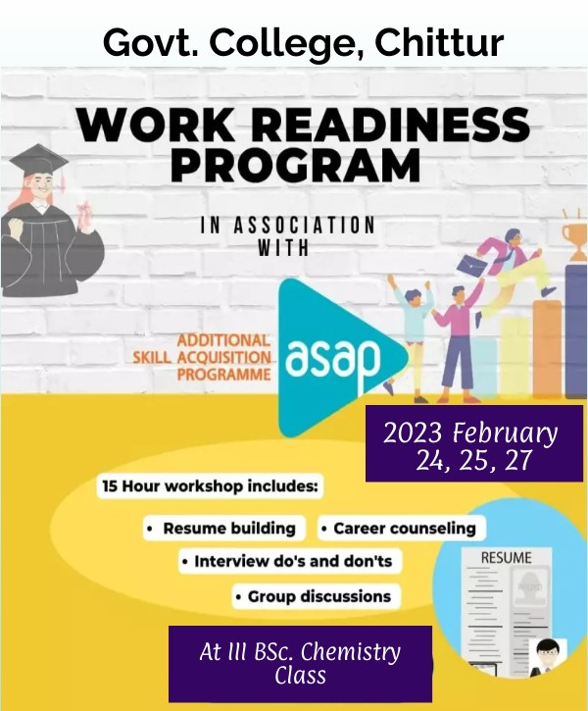

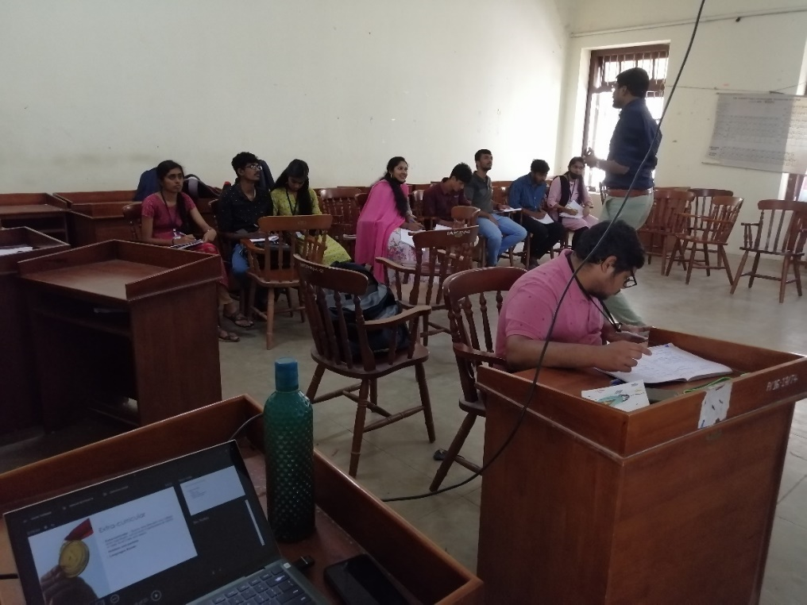

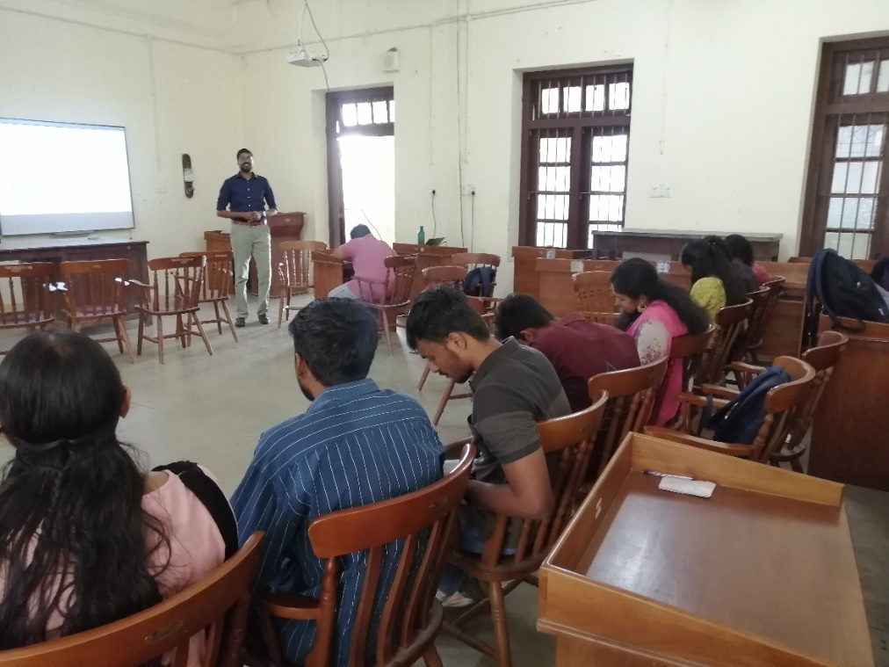

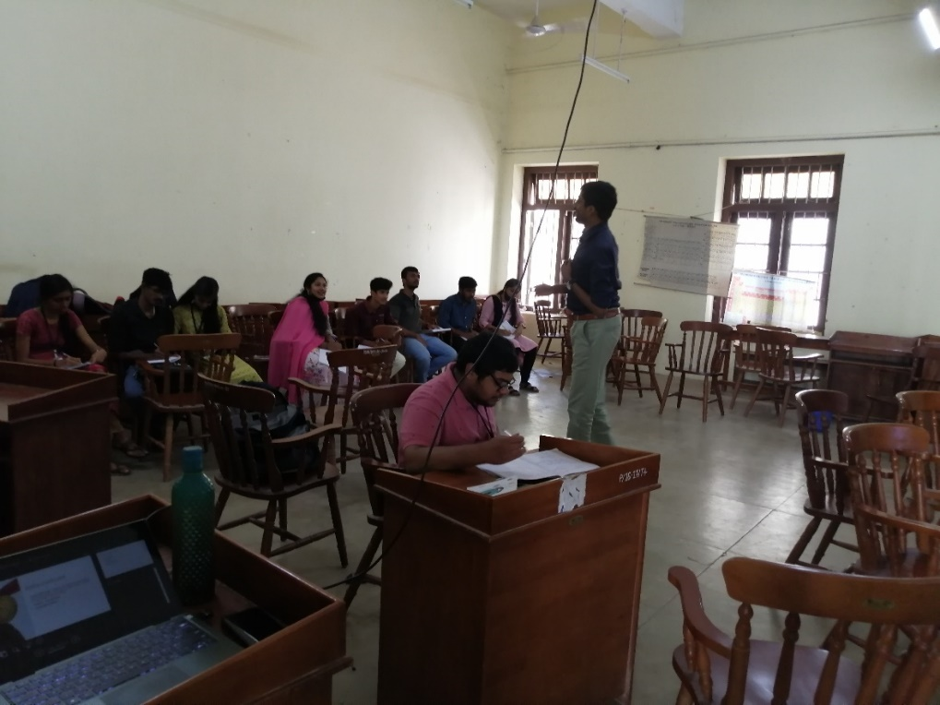

## Participants Details of WORK READINESS PROGRAMME

|  |  |  |  |
| --- | --- | --- | --- |
| Sl. No | Name | Class | DWMS ID |
| 1 | Muhammed Ashiq. M | III B.Sc. Zoology | KM00648763 |
| 2 | Sanika. M | III B.Sc. Zoology | KM01388639 |
| 3 | Aiswarya. M | III B.Sc. Zoology | KM01388752 |
| 4 | Abhinaya. S | III B.Sc. Chemistry | KM01387083 |
| 5 | Akhilraj. C. R | III B.Sc. Chemistry | KM01387069 |
| 6 | Mubashara. A | III B.Sc. Chemistry | KM01391027 |
| 7 | Akshaya. S | III B.Sc. English | KM01392768 |
| 8 | Navya Kannan | III B.Sc. English | KM01392766 |
| 9 | Sivanjaly. R | III B.Sc. Chemistry | KM01387086 |
| 10 | Shirin. S | III B.Sc. Chemistry | KM01440606 |
| 11 | Anila. K | III B.Sc. Chemistry | KM01389027 |
| 12 | Sreenath. G | III B.Sc. Chemistry | KM01387412 |
| 13 | Sandra. N | III B.Sc. Chemistry | KM00532835 |
| 14 | Sreelakshmy. J | III B.Sc. Chemistry | KM01387104 |
| 15 | Punnya. R | III B.Sc. Chemistry | KM01440743 |
| 16 | Anjana. R | III B.Sc. Chemistry | KM00347700 |
| 17 | Dhanya. S. Nair | III B.Sc. Chemistry | KM00778363 |
| 18 | Sruthi. V | III B.Sc. Chemistry | KM01387088 |
| 19 | Prathyusha. P | III B.Sc. Chemistry | KM01390991 |
| 20 | Wasim Farhan. A | III B.Sc. Chemistry | KM01388158 |
| 21 | Thithli. M | III B.Sc. Chemistry | KM01440814 |
| 22 | Naveen Jose. A | III B.Sc. Chemistry | KM01440790 |
| 23 | Abiya. P | III B.Sc. Chemistry | KM01440964 |
| 24 | Shincy. B | III B.Sc. Chemistry | KM01440968 |
| 25 | Akash. P | III B.Sc. Chemistry | KM01441433 |
| 26 | Anirudhan. K. P | III B.A History | KM01434542 |